

METU EEE

STATIC ENERGY CONVERION-I

HARDWARE PROJECT REPORT

Yunus Cem Duman-2093680

Mert Aydın-

Burak Kemal Kara-2114734

**Date:15.01.2020**

Contents

1.INTRODUCTION 3

2.The Description and The Aim of The Project 3

3. Design of the Project 5

3.1. The Main Topology 6

3.2. Thermal Design 6

3.3.The Implementations for Bonuses 6

3.3.1. H-Bridge 6

3.3.2.PCB Implementation 6

3.3.3.Industrial Box 6

3.3.4. Closed-loop Voltage/Current Control by Arduino 6

4. Test Resuls 7

5. Conclusion 7

6. Appendix 7

7. Referances 7

# 1.INTRODUCTION

The demand for the electrical power over the world increased by increasing population. Electrical vehicles, smart houses, wind trubines etc. , which has inevitable to improve by this increasing population, has made a great influence on the power systems and changed the traditional understanding of power system. These developments made the power systems and power electronics area much more important than before. These areas are completes each other. However the project is more about the power electronics area. The power electronics area has a huge scope of electrical engineering.This area contains rectifiers, inverters, DC/DC converters, motor drive circuitries, electrical vehicles, generators, motors etc. These circuitries are commonly used in our daily life and it is developing everyday. In order to understand and contribute the developments at this area, it is essential to have a good understanding of basic topologies of this area. So this project is all about having an understanding of one of the very basic applications of the power electronics area.

This project is a work of full understanding of DC motor drive. The main idea is to drive the DC motor that is applicable at laboratory, by using a variac, the device for arranging the voltage level that is taken from the grid and control the DC motor’s speed. The drive circuitry is a combination of some of the topologies that this discipline covers such as rectifier circuitry and DC/DC converter etc.

# 2.The Description and The Aim of The Project

The project is to design a DC motor drive that is applicable at laboratory and can be seen at Figure 1.

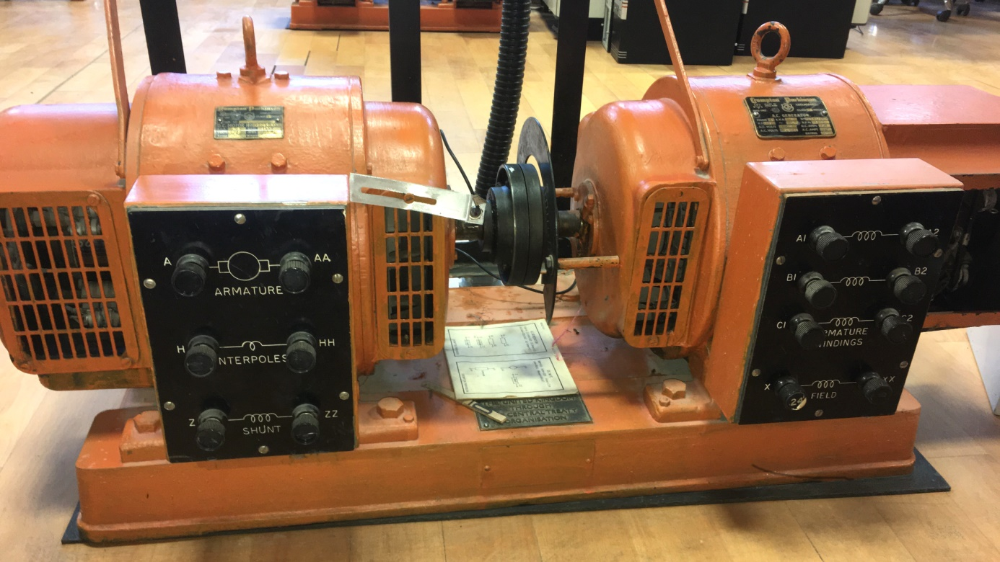

Figure 1:The DC Motor(Crompton Parkinson brand)

This motor is an experimental type motor and it’s rating values can be seen from the below figure.

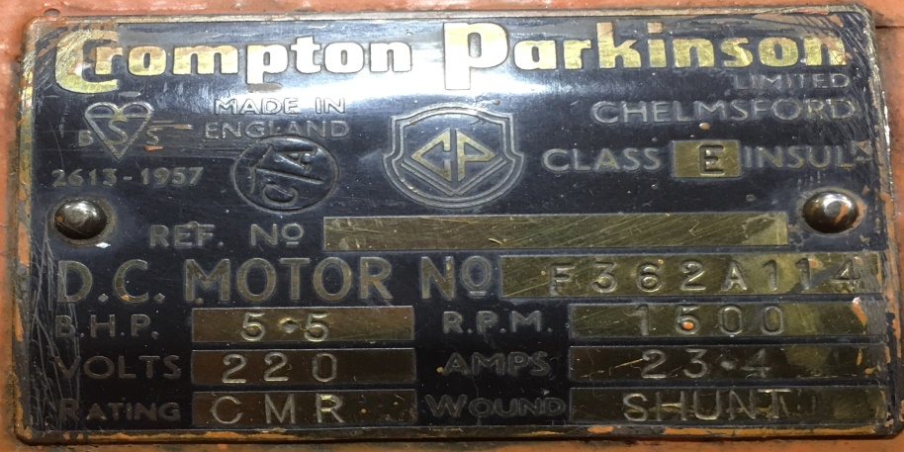

Figure 2:The Ratings of DC Motor

The motor has;

**-Armature Winding**: 0.8 $Ω ,12.5 mH$

**-Shunt Winding**: 210 Ω, 23 H

**-Interpoles Winding**: 0.27 Ω, 12 mH

**-Inertia**: TBA

In order to drive this DC motor many circuit topology can be used. However due to simplicity and applicability of the diode rectifier and a buck converter connected topology is choosen which can be seen at Figure 3.

# 3. Design of the Project

The main topology of the design is a three phase diode rectifier and a buck converter. The main working principle of the drive can be examined one by one. Firstly three pahse diode rectifier converts the AC voltage that is supplied by variac and converts it to DC voltage. Changing the variac voltage in order to control the speed of the motor is restricted. So it is impossible to control the DC voltage applied to motor by just using three phase diode rectifier. So the buck converter is used in order to control the DC voltage level that is applied to DC motor. According to the duty cycle applied to the switch (MOSFET) of the buck converter topology, can be seen at Figure 3, the voltage level that is applied to DC motor can be controlled. So that means another circuitry is necessary to drive the MOSFET also. So 555 timer is used in order to drive the mosfet of the buck converter. However that was not enough either. 555 Timer circuitry can not drive the mosfet circuitry alone, so octocoupler circuitry is necessary.

## 3.1. The Main Topology

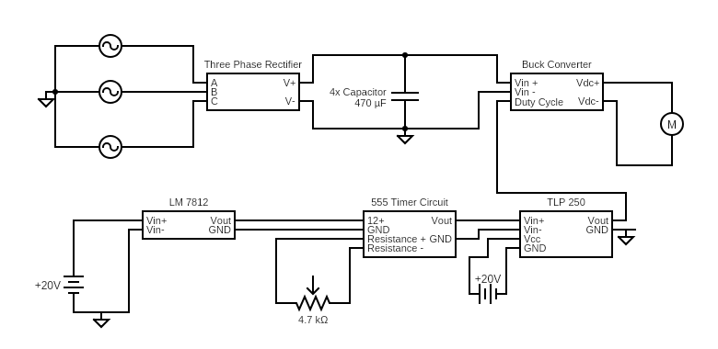

## 3.2. Thermal Design

Thermal design one of the most important considerations in the power electronic circuits because there a lot of power handling electronic components and unfortunately, these devices does not work at %100 efficiency. Therefore, some of the losses should be dissipated as heat through these components. However, these devices can not tolerate that much heat by itselves. Thus, additional mechanical parts should be integrated with them to ease the dissipation of the heat. Additionally, not just because the safety of the components, but also, performance and life-time of the components are mostly determined by thermal design so, it should be implemented for those reasons.

For our circuit, there are two parts that dissipate heat significantly, These are rectifier unit, and buck converter. Since we have one compact rectifier module and also diode and mosfet which form buck converter connected to same heatsink, two heatsinks are used totally.

while selecting heatsinks, not just driving at no load is considered but also robustness bonus is considered. Therefore, calculations are made for both requirements as follows.

**Calculations:**

for the first, the heatsink for buck converter is calculated

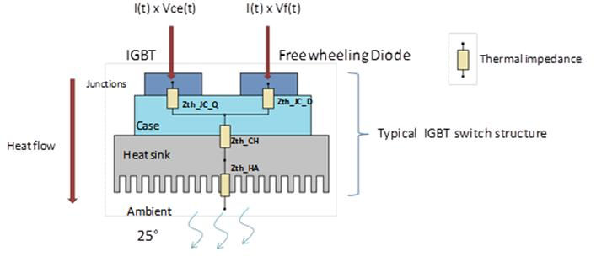

figure??: thermic lumped parameter model of the buck converter.

* First we assume the thermal contact between the heatsink and component are neglible so, we neglect that part.
* Secondly, we should calculate total power loss to select the suitable heatsink.

For that purpose, we should look back to datasheet of the diode and IGBT to obtain the pararameters for both conduction losses and switching losses.

firstly , we use DHG30I600PA diode and its parameters are as follows:

**(*) V**fo=1.17V.

(**) rF=32 mΩ.

And for the Switching losses,

(we already know the fs=500Hz and Vr =200V at most)

We just need to find Qr from following graph.

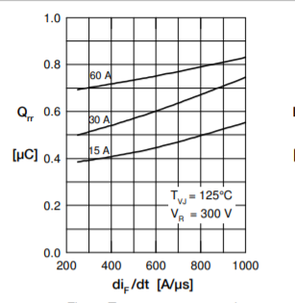

Figure?? Qr vs dif/dt from datasheet.

From above figure we Assume Qr as 0.3 uA at worst situation because the current that pass through the diode never exceeds the 10A.

So, we can insert those values to the equations,

Pcd= (1.170.032)10(we assume at most diode conduct 10 A which is still lover than rated operation of the project

Psd=0.30 (since frequency is low it is normal)

Psd+Pcd=15 Watt at total contribution from diode.

Now we can calculate the losses for the IGBT.

For the conduction losses of IGBT,

**Vce**=1.6 V (collector emitter sat. voltage)

**If=**10 A ( for a safety margin. normally it depends on duty cycle)

Pic= 16 Watt .

For the Switching losses, we should obtain the energy required for opening and closing.

We choose the “IGW30N60T” IGBT and from its datasheet, ETOTAL=1.8 mJ

the frequency of operation is around 500Hz and that energy will be given and taken in one interval of operation. Therefore, we should multiply fS with the ETOTAL to find switching loss.

Pis=fS (it expected since frequency is so low)

Therefore, total contribution from IGBT is 17 watt.

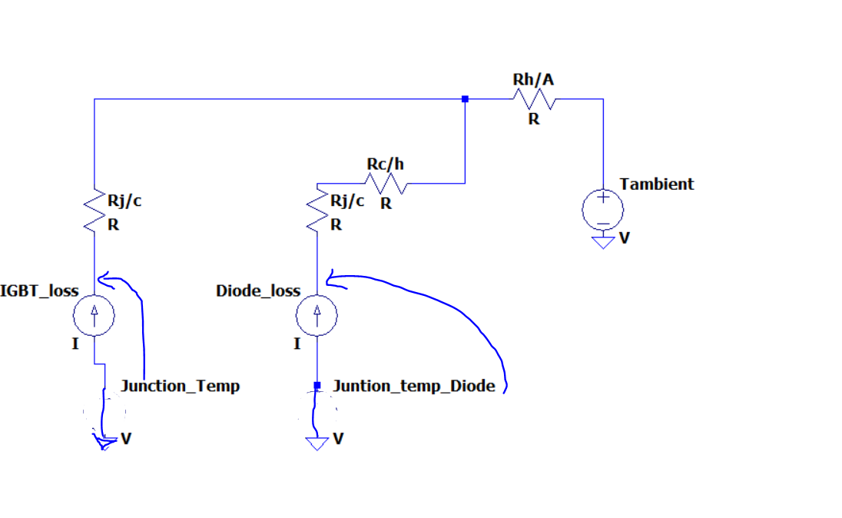

Figure??: detailed lumped model of thermal design.

* Thirdly, we should find the thermal resistances from the datasheets and guessing a reasonable heatsink value from these results.

**Rj/c(diode)=0.7 C/W , Rc/H(diode) =0.5 C/W Rtotal=1.2C/W**

**Rj/c(IGBT)=0.8 C/W**

if we assume heatsink has 1.0 C/W thermal resistance then the junction temperatures will become as below:

Tj(diode)=25+15321=75 C.

Tj(IGBT)=25+170.8+321=70.6 C.

These are far less values that the maximum operating junction temperature which is 175 C degrees so, we select a heatsink which has 0.9 C/W thermal resistance to realize the that idea.

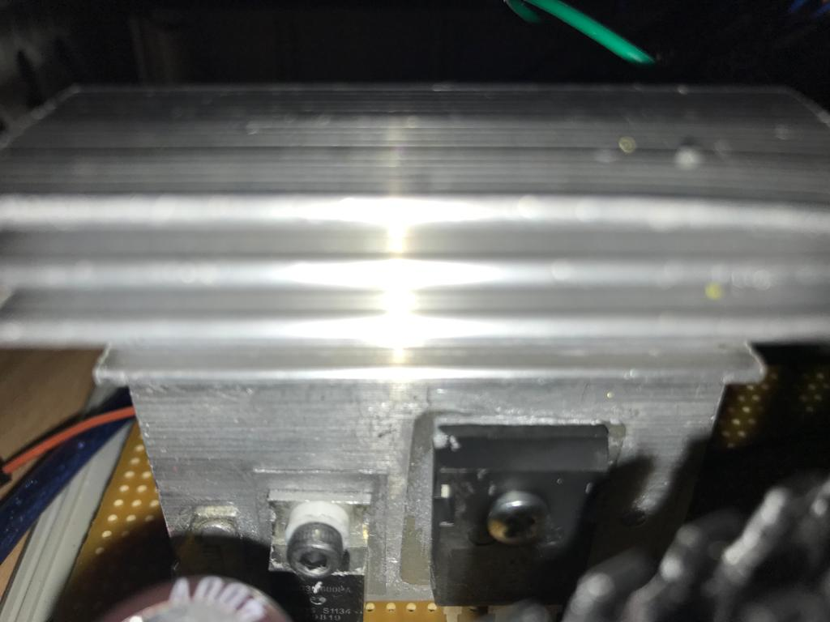

Figure??: Resultant hardware configuration of thermal design (for buck converter)

For the Second, we will calculate the heatsink required for the Three-phase full bridge rectifier,

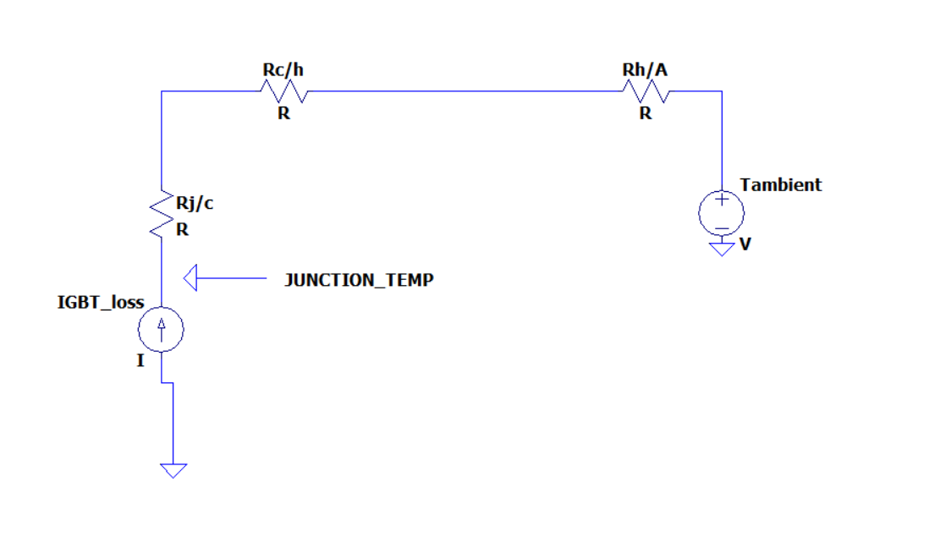

Figure:?? the detailed lumped model of the bridge module.

So, Again we should calculate the losses and applying the same procedures above for the selecting a suitable heatsink.

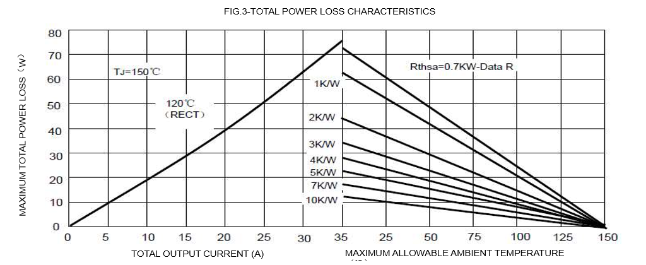

Figure??: power loss characteristic of the bridge module. (from datasheet)

Since we have a bridge module rather than six single diodes, accessing the datasheet of the diodes inside of the module is not possible. In datasheet provided for complete module includes some general power loss characteristic as in the figure above. this curve gives the maximum power loss therefore, it will be safe to use it although it may results with unnecessarily large heatsink.

Ploss= 20 Watt (at 10A output).

So, it is now time to find thermal parameters from the same datasheet.

**Rj/c**=1.16 C/W.

**Rc/h=**0.2 C/W.

So, we try with a 1.8C/W heatsink and result will be:

Tj=(1.16+0.2+1.8)20=88 C

So, it is again relatively safe for the operation of this project.

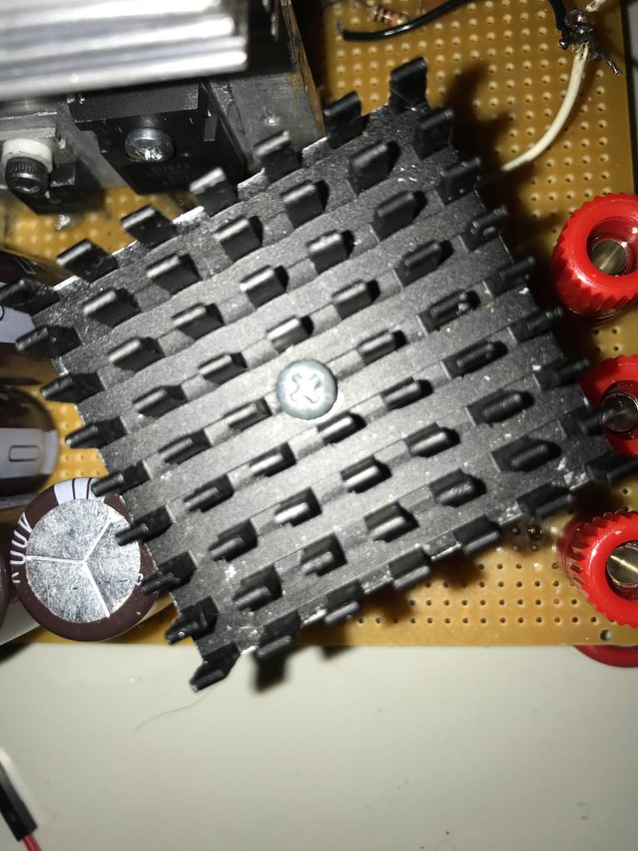

Figure:?? the heatsink for the full bridge rectifier.

<https://www.aliexpress.com/i/32634872516.html>

## 3.3.The Implementations for Bonuses

After completing the main circuitry, the bonus applications were designed. These are H-Bridge circuitry, PCB design, industrial box implementation, Closed-loop Voltage/Current Control by Arduino. At this section of the report, the details of these will be introduced.

### 3.3.1. H-Bridge

### 3.3.2.PCB Implementation

### 3.3.3.Industrial Box

### 3.3.4. Closed-loop Voltage/Current Control by Arduino

# 4. Test Resuls

# 5. Conclusion

# 6. Appendix

# 7. Referances